

Quality Update

The Official Newsletter of Bovey Tracey Town Council – Issue 25 – March 2009
Bovey Tracey Town Council – 01626 834217 – Bovey Tracey Website - www.boveytracey.gov.uk

Fairtrade Fortnight 2009

23rd February – 8th March 2009

There are a number of events celebrating Fairtrade Fortnight taking place this year in Bovey Tracey and Heathfield. On 2nd March there will be a Fairtrade school conference in the Town Hall and local primary schools in the area have been invited to send representatives. There will be quizzes and games as well as the chance to hear from a French speaking mango producer from Burkina Faso in Africa called Arsene Sourabie. The aim of the conference is for children to take back information on Fairtrade to their schools and work towards their Fairtrade schools award and have some fun of course!


The Town Hall will again provide the venue for a celebration of Fairtrade Fortnight on Wednesday 4th March from 6.00pm to 7.00pm. The Bovey Tracey Fairtrade Town Steering Group is hosting the event and through ‘Fairtrade Devon’ has invited Riziq Abu Nasser an olive farmer from the West Bank of Palestine to come to talk to us about what Fairtrade means to him, his family and locality. The aim of this evening is to celebrate being a Fairtrade Town and encourage those who have not got involved with Fairtrade to consider doing so and meet some of those who are already supporting it.


On Friday 6th March there is a World Record Fairtrade Banana eating contest and local schools are taking part in this sometime during the day! You can also ‘Go Bananas’ so why not take part yourself and register with the Fairtrade Foundation! For further information please visit www.fairtrade.org.uk.

Since Bovey became a Fairtrade Town the Traidcraft Stall is also available in the Town’s Produce Market once a month to promote Fairtrade in the locality and to encourage people to try Fairtrade products. This is proving to be very popular with visitors to the market. It seems very appropriate to support our local farmers, whilst at the same time supporting those in developing countries too.

If you are interested in attending the Fairtrade Event on 4th March please contact Liz Westwood on 01626 836107.


Annual Town Meeting 2009

You are invited to attend the Annual Town Meeting in the Town Hall, Bovey Tracey on Wednesday 25th March 2009, starting at 7.30pm.

Please come along to see and hear about what has been happening in the Parish over the past 12 months. This will include an update on the activities of the Town Council and reports from local organisations and primary schools.

Part of the evening will also feature a short illustrated talk entitled ‘Bovey’s Past in Pictures & Postcards’ by Liz Westwood. This is an interesting and delightful pictorial record using old picture postcards and photographs of Bovey Tracey from the late 1800’s.

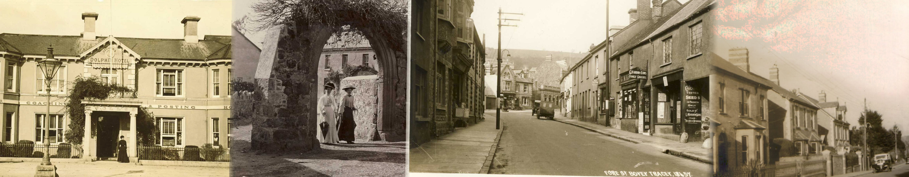
BOVEY TRACEY
TOWN COUNCIL
IS SEEKING NOMINATIONS FOR THE HONORARY TITLE OF:
REPRESENTATIVE OF THE LORD OF THE MANOR OF BOVEY TRACEY

THIS IS awarded annually in May at the Town Council’s Annual Meeting on 11th May 2009 to a Bovey Tracey or Heathfield resident, who in the opinion of the Town Council, for whatever reason, has made a significant contribution to the Parish of Bovey Tracey and should be publicly recognised for those actions.

If you know of someone who should be considered for this award, nominations, proposed & seconded, should be made in writing, with the consent of the nominee, and submitted to:
Bovey Tracey Town Council,
Town Hall, Bovey Tracey
By noon on 3rd April 2009.

For any further information required please contact:

Terry Westwood – Town Clerk
(01626 834217 -mornings only)

Dear Resident,

Here we are, in 2009 with spring on the horizon and, hopefully, good weather to look forward to! Since my last letter to you a few things have happened. We are now preparing Staddons Orchard for fifteen new allotments and hope that this area is very productive (plenty of manure is the secret!)
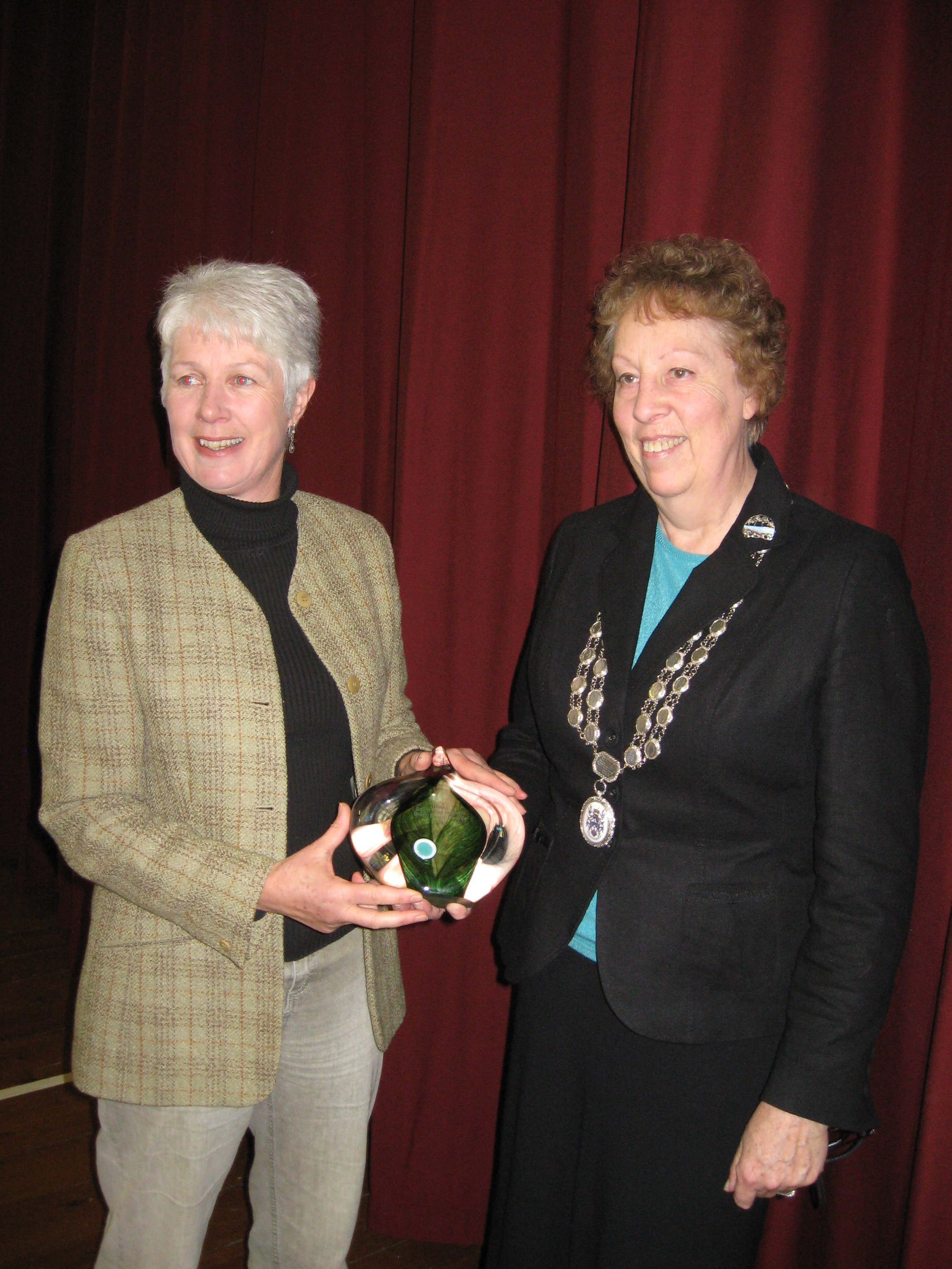

Bovey Climate Action (BCA) has recently won the RegenSW award for Best Sustainable Energy Community for Bovey Tracey. The award recognises the group's success in raising awareness of climate change issues, and reducing carbon emissions in Bovey Tracey. Kathy King, Chairman of BCA, presented the award on behalf of the group to the Town Council at the January Town Council meeting.

We are now working towards improving the play areas in Heathfield. A consultation event is taking place at St Catherine’s School on the 28th February from 2.00pm to 4.00pm to listen to the children and parents about what they would like to see included. It is always useful to first have an input from the residents who are going to use the facilities so that we get it right.

The Council has been informed it has retained its Quality Status for a further four years, which is an excellent start to 2009 for our Parish, which all residents can be proud of. Many thanks to our Town Clerk for all his hard work in putting this together. Several thousand daffodil bulbs have been planted throughout the Parish. See if you can spot where and when the first bulbs flower! Our thanks go to the Brookside Tea Rooms, Dolphin Hotel and Cottage Tea Rooms for their sponsorship and help in planting the bulbs.

It has been brought to our attention that dog-fouling of our pavements is again on the increase. This is a problem that is easily rectified – please pick up after your dog. There are dog bins provided so no excuses. Dog mess is unsightly, potentially dangerous and also against the law!

Two dates for your diary – Fairtrade Fortnight – 23rd February to 8th March and the Annual Town Meeting, to which all are welcome, on 25th March in the Town Hall – so hope to see you there.

Councillor Dorreen Black - Town Mayor

Bovey Tracey Town Council Meetings

Starting time 7.00pm
Public Speaking Period at the start of each meeting

23rd March 2009
11th May 2009
Annual Meeting of the Town Council

Meetings are held in the Council Chamber, Town Hall, Bovey Tracey

Your Town Councillors’ contact numbers:

Town Mayor – Dorreen Black 834297
Deputy Mayor – Michelle Davey 836607
Bovey Councillors:
Tony Allen 836239
Robert Bray 835591
David Elphick 832125
Alan Griesiell 833348
George Gribble 832764
Michael Harper 836227
Fernley Holmes* 833171
Avril Kerswell 832923
Anna Klinkenberg* 834328
Sally Morgan*/** 830257
Tina Richardson 835363
Heathfield Councillors:
Kelly Westbury 830494
Michelle Davey 836607

*District Councillor */** County Councillor
Town Clerk - Terry Westwood 834217


DOG FOULING

There have been an increasing number of complaints made to the Town Council from residents from Mary Street, East Street, De Tracey Park and Coombe Cross regarding amount of dog dirt found on our pavements throughout the Parish. The laziness of individuals who cannot be bothered to pick up their dog’s mess is not acceptable.

Therefore the Town Council has taken action and is now working with Teignbridge District Council’s Dog Warden to identify the individuals responsible. If anyone is caught not collecting their dog’s dirt a fine of up to £75.00 can be made. If you have any information which could be helpful please call 01626 215838 and speak to the Dog Warden.
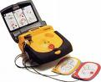
Defibrillators

If someone collapses with a sudden cardiac arrest you have only a very few minutes to help them. We have two defibrillator units for emergency use located in Bovey Tracey. One is at the Dolphin Hotel (832413) and the other is at Sibley’s Garage, Fore Street (832424). Staff at both places are trained in using this important equipment in an emergency situtaion.
‘In Case of Emergency’


For those who carry a mobile phone with names & numbers stored in its memory. If we were to be involved in an accident or were taken ill, the people attending us would have our mobile phone but wouldn't know who to call. Yes, there are hundreds of numbers stored but which one is the contact person in case of an emergency? Hence this 'ICE' (In Case of Emergency) Campaign.
The concept of 'ICE' is catching on quickly. It is a method of contact during emergency situations. As mobile phones are carried by the majority of the population, all you need to do is store the number of a contact person or persons who should be contacted during emergency under the name 'ICE' (In Case Of Emergency). The idea was thought up by a paramedic who found that when he went to the scenes of accidents there were always mobile phones with patients but they didn't know which number to call.
He therefore thought that it would be a good idea if there was a nationally recognised name for this purpose. In an emergency situation, Emergency Service personnel and hospital Staff would be able to quickly contact the right person by simply
dialling the number you have stored as 'ICE'.
Please consider supporting this campaign. It really could save your life, or put a loved one's
mind at rest. For more than one contact name simply enter ICE1, ICE2 and ICE3 etc.
750th Charter Celebrations 2010 Update

In 1260 Sir Henry De Tracey, who was the first Lord of the Manor of Bovey Tracey, obtained a charter from the Crown allowing a weekly market and an annual fair in the town. Charter Week is planned to run from 3rd July to 11th July 2010 to celebrate the 750th anniversary of the signing of the Charter.

The Charter Committee has now met on numerous occasions over the past 12 months and the provisional programme of events is outlined below. There are also a number of other events planned for outside this period.

2nd & 3rd May 2010 Beating the Bounds
3rd July 2010 Charter Ball
4th July 2010 Charter Half Marathon & Fun Run
7th & 8th 2010 July Community Play
9th to 11th 2010 July Charter Celebrations

A range of events are planned for the Charter Weekend including a Town Crier’s competition, Flower Festival, Maypole Dancing, the Charter Fair in Mill Marsh Park on 10th July to include a Civil War re-enactment and the final event is the Charter Celebration Party & Fireworks in Mill Marsh Park with AJ’s Big Band on 11th July. More details can be found by visiting www.boveytracey.gov.uk and clicking on Charter. The committee is also aware that England maybe playing in the World Cup football final on this Sunday as well!!!!
2009 Precept

After careful consideration and listening to the needs of its Parishioners, Bovey Tracey Town Council has set its precept for the next twelve months starting on 1st April. The precept is the amount of money required by the Town Council to undertake its various services on behalf of residents.

These include the management of Mill Marsh Park, the Town Hall, the Cemetery, the Recreation Ground, Allotments and other open spaces in the Parish along with contributions to the summer floral displays, Christmas lights and grants to local organisations. Last year’s precept was £148,855. This year’s total precept will be the same at £148,855. This relates to an annual total charge of £50.39 per year for a Band D property. Last year’s Band D charge was £50.44.

The need to retain the precept at the same level relates to the need to again raise an additional £51,440 for specific projects in Bovey Tracey and Heathfield planned for the next 12 months. £45,440 of this total has been allocated towards two major projects. Working in partnership with Teignbridge District Council, £30,440 is being invested in major improvements to the play area at Brow Hill in Heathfield. The District Council are also investing £30,000 in this project.

Due to the present lack of support from Devon Youth Services in supporting the work with young people throughout the Parish, as a positive move £15,000 has been allocated to supporting the work of Bovey Tracey Youth Action, which operates the Youth Café and the dedicated group of volunteers who run Heathfield Youth Club.

Energy Usage in Our Homes

Most of us have an idea of how many miles per gallon our car does and certainly when our fuel is about to run out! Helpful meters and counters help to make this clear to the car user. But what about the fuel we use at home? We pay (increasing!!) bills for electricity and gas but are disconnected from where and how we used that amount.

Bovey Climate Action (BCA) energy group want to help you REDUCE your energy consumption. BCA can lend you a portable and simple to use meter, which measures electrical usage in your home provide help to install it and help you understand and monitor the results. The group has already run trials in Bovey Tracey and users could reduce their electricity usage by understanding the cost of different appliances and by changing, from old inefficient appliances to more energy saving appliances.

BCA can also help you look at the different energy deals available as well as helping you to talk to the right people about loft and wall insulation. BCA is there to help you - we are a local group, seeking to reduce the energy consumed in Bovey Tracey. Contact BCA Energy Group On 0845 478 6311 to register your interest and a BCA member will be in touch. Alternatively send an email to info@boveyclimateaction.org.uk

