**Bovey Tracey Town Council**



Riverside Community Centre

Station Road

Bovey Tracey

TQ13 9AW

**Telephone:01626 834217**

**Email:** [**info@boveytracey.gov.uk**](mailto:info@boveytracey.gov.uk)

**Town Clerk:** Mr Mark Wells

TENDER FOR:

Grounds Maintenance Contract

January 2025- January 2027

TENDER SUBMISSION DEADLINE:

**Monday 19th August 2024**

**Timescales relating to this Tender are as follows:**

Issue of tender document and advertising Friday 31st May 2024

Closing date for receipt of Expression of Interest Friday 28th June 2024

Closing date for questions relating to Tender Monday 8th July 2024

Closing date for receipt of Tender **Monday 19th August** **2024 (midday)**

Selection considered at Finance Meeting Monday 2nd September 2024

Earliest tender award date Tuesday 17th September 2024

Contract start date January 2025

**1.1** Bovey Tracey Town Council is responsible for the provision of grounds maintenance for a number of green spaces across the parish of Bovey Tracey, which includes the ward of Heathfield.

**1.2** For these areas (highlighted on the attached map) the Town Council now wishes to tender for a Grass Cutting service: (full details provided in Section 4)

**1.3** An Expression of Interest (Appendix A) must be submitted according to the instructions therein by **midday on Friday 28th June 2024**. Failure to do so may exclude any applicants from the tender process.

**1.4** Any questions relating to this tender must be raised in writing no later than **Monday 8th July** **2024.** Questions should be addressed to the Town Clerk: Mr Mark Wells [preferably by email: info@boveytracey.gov.uk or by letter to Bovey Tracey Town Council,](mailto:%20info@boveytracey.gov.uk) Riverside Community Centre, Station Road, Bovey Tracey, TQ13 9AW. Any questions raised and the answers returned will be distributed to all companies that submit an Expression of Interest.

**1.5** All tender submissions must be received by noon on **Monday 19th August 2024** using the envelope template (provided in response to receipt of an Expression of Interest). Tenders are to be opened by the Town Clerk in the presence of at least one Town Councillor. Any tenders received after deadline, incomplete or without first sending an Expression of Interest may not be considered.

**1.6** Any Contractor who canvasses any Member or Officer of the Council, directly or indirectly, relating to the award of this contract will be disqualified.

**1.7** If any Contractor:

**a)** Fixes or adjusts the amount of the tender by arrangement with any other persons; or **b)** Communicates to any person other than the Council the amount of tender (unless disclosure is made for insurance purposes, for example); or

**c)** Agrees with any other person that they will agree not to tender or as to the amount of any

other tender to be submitted; or

**d)** Offers or pays any sum of money to any person to induce such a person to accept the tender

then the Contractor shall be disqualified from tendering and may be subject to civil and criminal liability.

**1.8** Tenderers should note that, as part of the evaluation process, they *may* be asked to attend a meeting at which they might be expected to present and answer questions on their bid. Tenderers will be contacted if it is decided that a meeting needs to be arranged and such meetings will take place in the Town Council Offices, or as arranged.

**1.9** Tenders will be evaluated in accordance with the information provided within the Tender Form submission and accompanying table of costs (Appendix B).

**1.10** The Town Council is not bound to accept any tender, but every effort will be made to reach a decision on the award of contracts by mid-September 2024.

**1.11** Evidence of the Contractor’s **flexibility and response to operational changes during the term of the contract is crucial.**

**Section 2 (Instructions)**

**2.1** You should only complete the Tender after reading and fully understanding the tender document. Where necessary, any additional information must be obtained at the expense of the tenderer in preparation of their submission.

**2.2** If you have any doubt at all on how to complete the tender please contact the Town Clerk, Mr Mark Wells by email at [info@boveytracey.gov.uk](mailto:info@boveytracey.gov.uk)

**2.3** Please note that once the tender has been submitted, you will not have the opportunity to alter its contents. Once a Tender has been awarded no allowance can be made for any errors, omissions or misjudgements by the Contractor in Tendering.

**2.4** All tenders submitted must be in accordance with the specification provided (Section 4).

Tender forms must be completed in full and signed.

**2.5** Tenders must be accompanied by:

i) A method statement of how the Contractor would provide the service(s). The Town Council will reserve the right to confidentially discuss these statements with the Contractor.

ii) All relevant documentation that demonstrates compliance with current Health and

Safety Legislation as detailed in Section 3.

iii) Rates and prices exclusive of VAT including all travel time and expenses (no additional payment will be made in respect of any changes in the cost to the contractor of labour, materials and plant employed in providing the service).

iv) Where applicable, the documents listed within the enclosure checklist (section 3).

v) Any policies or assessments that highlight the Contractors environmental values/credentials.

**2.6** Tender forms must be submitted in the envelope provided, before the deadline at **noon on Monday 19th August 2024**. Any tenders received after this time may not be considered, and will be returned to the respondent.

**To:** Bovey Tracey Town Council

Riverside Community Centre

Station Road

Bovey Tracey

TQ13 9AW

**Telephone:** 01626 834217

**Email:** [info@boveytracey.gov.uk](mailto:info@boveytracey.gov.uk)

**Town Clerk:** Mr Mark Wells

**3.1** I/We tender to carry out the work and/or provide the services/goods or materials referred

to in the contract specification (Section 4) in accordance with the details set out overleaf. I/We agree that this tender together with the Council’s written acceptance will constitute a contract between us.

**3.2** I/We certify that this is a bona fide tender and that I/we have not fixed or adjusted the amount of the tender by or under or in accordance with any agreement or arrangement with any other person. I/We also certify that I/we have not done and I/we agree not to do at any time before the tender closing date any of the following:

Communicate to a person the amount or approximate amount of the proposed tender, except where the disclosure is in confidence and necessary to obtain insurance premium quotations required in connection with the preparation of the tender submission.

Enter into any arrangement or agreement with any person(s) that they should refrain from tendering or as to the amount of any submission.

Offer to pay any sum of money or gift to any person for doing so any of the acts above.

**3.3** Organisation Identity (*Block Capitals Only*)

**Name of Company Contact Name Registered Address**

**Telephone No(s) Email**

**Primary Address** *(From which the services will be provided, if different from above)*

**3.4** Please indicate below the principal business activity of your organisation and main geographical area (you may attach a separate sheet headed ‘**3.4- Business activity**’ if required.

**3.5** Legal information:

What is the status of your organisation? (e.g., sole trader, limited liability partnership, public limited company, private limited company, charity etc)

Date of formation of organisation:

VAT Registration Number *(indicate if Not Applicable)*:

Are there any court actions and/or tribunal hearings outstanding against your organisation? **YES / NO**

Has your organisation been involved in any court action and/or tribunal hearings over the last three years? **YES / NO**

If you have answered **YES** to either question, please provide details on a separate sheet headed ‘**3.5- Legal Information**’

Please give the names and responsibilities of any Directors/Partners of your organisation

**3.6** Tenderers will be required to remove (where stipulated) from sites all waste materials including, but not limited to: grass, wood, bark, paper, metals, plastics, glass. Tenderers should

indicate how they separate and dispose of the materials described in this clause. (If continuing

on a separate sheet use the heading ‘**3.6- Waste Disposal**’ or if already outlined in summary of work, please reference below).

**3.7** Tenderers will be required to provide environmental policies and indicate what measures they have in place to mitigate their carbon footprint (Bovey Tracey Town Council declared a Climate Emergency in 2019). (If continuing on a separate sheet use the heading ‘**3.7 - Environmental Policies’** or if already outlined in summary of work, please reference below).

Please include for example, policies relating to:

- Environmental Policy

- Energy & Net Zero

- Environmental Risk Management

- Sustainable Procurement

**3.8** All Contractors undertaking works under this tender must satisfy Bovey Tracey Town

Council of their competency regarding Health and Safety:

Please enclose:

o A copy of you organisation’s Health and Safety Policy which should include details of how compliance is measured.

o Copies of Risk Assessments for all processes of work that will be undertaken as part of this tender.

Please use the header ‘**3.7- Health and Safety/Risk Assessments**’.

**3.9** Please provide details below for at least three references for current or recent contracts/ provision of services relevant to this tender (If continuing on a separate sheet use the heading ‘**3.8- References**’). The Town Council may contact these referees as part of the evaluation process any time following receipt of tender submissions and our permission to do so will be assumed:

**Referee 1**

**Contact Name Telephone No(s) Email**

**Address**

**Brief Description of Contract**

**Referee 2**

**Contact Name Telephone No(s) Email**

**Address**

**Brief Description of Contract**

**Referee 3**

**Contact Name Telephone No(s) Email**

**Address**

**Brief Description of Contract**

**3.10** Please provide details of your organisation’s insurance protection in relation to employer’s

liability, public liability and professional indemnity:

**POLICY INSURER VALUE (£)**

Employers Liability

Public Liability

Professional Liability

*Please enclose copies of the relevant certificates*

**3.11** On a separate sheet headed ‘**3.10- Additional Information**’:

i) Please describe your organisation’s previous experience of providing similar services to those required in this tender.

ii) Indicate your maximum response time for non-routine works, Monday to Friday and

Weekends between 0800 and 1800.

iii) Any additional information you feel is relevant.

**3.12** Pricing Instructions are as follows:

i) The scope of works is outlined in Section 4, Tenderers are required to review this and respond with appropriate costs by completing Appendix B.

ii) Prices indicated would apply for year one (2025) and year two (2026) and prices will be subject to appropriate inflation uplift if extended beyond this period.

iii) Actual frequencies of cuts are to be agreed with the Town Council as the season progresses.

**3.13** Payment Terms are as follows:

i) The Town Council will only make payment against itemised supplier invoices that are issued with a completed attendance sheet (see Appendix D);

ii) Payments are made by BACS;

iii) Invoices must be received in a timely manner by the Town Clerk;

iv) Invoices received for additional work not authorised by the Town Council will be rejected;

v) If the supplier is declared bankrupt, is liquidated or placed into administration the contract will immediately become null and void

vi) If the supplier is found guilty of committing fraudulent acts (associated with this Contract or otherwise) the Town Council will have the right to terminate the contract without prior notice.

**3.14** A site visit may be arranged prior to the tender closure date. If a formal site visit is not arranged, tenderers are expected to make their own site visits. Tenderers are required to satisfy themselves that they have sufficient information to prepare a detailed price offer. Any errors made due to failure to obtain any information will be the responsibility of the tenderer.

**Signed Print Date**

**Enclosure Check List**

Please check that you have enclosed the following documents (*where applicable*) with your completed questionnaire. Please ensure that all attachments are clearly titled and referenced

as detailed in the related section.

i) Method Statement

ii) Costs Table (Appendix B)

iii) Insurance Certificate(s)

iv) 3.4 - Business activity

v) 3.5 – Legal Information

vi) 3.6 - Waste Disposal & Environmental Policies

vii) 3.7 - Health and Safety

viii) 3.8 - References

ix) 3.10 – Additional information

**Timescales relating to this Tender are as follows:**

Issue of tender document and advertising Friday 31st May 2024

Closing date for receipt of Expression of Interest Friday 28th June 2024

Closing date for questions relating to Tender Monday 8th July 2024

Closing date for receipt of Tender **Monday 19th August** **2024 (midday)**

Selection considered at Finance Meeting Monday 2nd September 2024

Earliest tender award date Tuesday 17th September 2024

Contract start date January 2025

**Section 4 (Specification)**

The Town Council has created the following specification for the work to be included in the contract. Please note that the areas included within the contract can be seen in the attached plans (Appendix C).

**4.1 Grass Cutting:**

Grass cutting will be undertaken between April and November throughout each year according to the table of costs in Appendix B.

Prior to grass cutting, all litter will be removed to prevent injury to persons or damage to property. Litter includes paper, tins, bottles, dog waste, fallen twigs, branches and stones which are more than 30mm in diameter.

Rotary or cylinder machines may be employed along with strimmers for areas around trees, obstacles and headstones. Please note care should be taken when cutting grass around young/vulnerable trees, headstones etc.

Mowing shall take place on the full area of grass, up to the boundary.

The contractor will clear all grass clippings arising from mowing operations from hard surfaces, paths, paved areas, headstones, memorials and any other horticultural features.

When working in the Cemetery, contractors are expected to stop work and maintain silence when any interment takes place. Details of interments are available from the Town Council Office prior to commencing work which you will be required to check.

During extremely wet conditions where damage to the surface is likely to occur, grass cutting will stop and the Contractor must notify the Town Clerk.

Any areas that have not been maintained in accordance with this specification must be re-cut at the cost of the Contractor.

Contractors will provide their own skilled labour and well-maintained machinery.

An attendance sheet must be submitted to the Town Council office immediately following the completion of work undertaken (see Appendix D)

**4.2 Damage to properties:**

Any damage caused to property (i.e. Vehicles, benches, headstones) during grass cutting will be reported to the Town Clerk, and where possible, the owner. Any costs arising for repairs will be covered by the Contractor, as per their company regulations.

The Contractor is required to protect buildings, fences, gates, walls, landform, vegetation and other site features that are to remain in position during the performance of the Service.

Any damage caused due to the Contractor’s negligence will be reported immediately to the Town Clerk, and will be reinstated at the Contractor’s expense.

Any item found to be in a dangerous condition shall be immediately made safe or removed to a store provided by the Contractor as soon as the defect is noticed.

**Section 5 (Conditions)**

**5.1** Bovey Tracey Town Council reserves the right to accept the quotation in total, in part only, or not at all.

**5.2** Bovey Tracey Town Council is not obliged to accept the lowest quotation price submitted. The emphasis for acceptance will not only depend upon price, but on quality of service provided, working relationships between parties, flexibility and any added value a contractor can bring to this contract. Further details of added value that is offered should be detailed within any submission.

**5.3** Contractors will comply fully with Health and Safety Legislation pertaining to this type of work.

**5.4** All accounts to be invoiced on a monthly basis attached with a copy of the attendance sheet/s showing the work invoiced for (see Appendix D)

**5.5** If acceptable standards and quality of service are maintained throughout the initial contract period, Bovey Tracey Town Council reserves the right to extend the contract for a further 12 months or two years.

**5.6** When submitting your quotation, please indicate if you would normally include VAT on your invoices, or as a separate item.

**5.7** Quotations must be submitted using the envelope template provided no later than midday on **Monday**

**15th August 2022**.

**5.8** Bovey Tracey Town Council reserves the right to vary in new sites or remove existing sites/areas as changing circumstances might dictate.

**5.9** The frequencies within the table of costs (Appendix B) are provided as a guideline only. The weather and events will have an impact on the potential to change frequencies to either more cuts or less cuts and this will be managed directly between the Contractor and Bovey Tracey Town Council.

**APPENDIX A- EXPRESSION OF INTEREST FORM**

**Bovey Tracey Town Council**



Riverside Community Centre

Station Road

Bovey Tracey

TQ13 9AW

**Telephone: 01626 834217**

**Town Clerk:** Mr Mark Wells

**To:** Bovey Tracey Town Council

Riverside Community Centre

Station Road, Bovey Tracey, TQ13 9AW

**Telephone:** 01626 834217

**Email:** [info@boveytracey.gov.uk](mailto:info@boveytracey.gov.uk)

**Town Clerk:** Mr Mark Wells

*Please Note:*

***THIS FORM MUST BE RECEIVED BY NOON ON FRIDAY 28TH JUNE 2024***

***FAILURE TO DO SO MAY RESULT IN EXCLUSION FROM THE TENDERING PROCESS.***

**Date:**

**Company Name: Contact Name:**

We confirm our interest in tendering for the grounds maintenance contract as detailed in **Section 1** in the tender document. Any further information in respect of this tender, including answers to questions raised by any tendering organisation should be addressed to the following:

**Name: Address:**

**Telephone No(s): Email:**

**Signed**

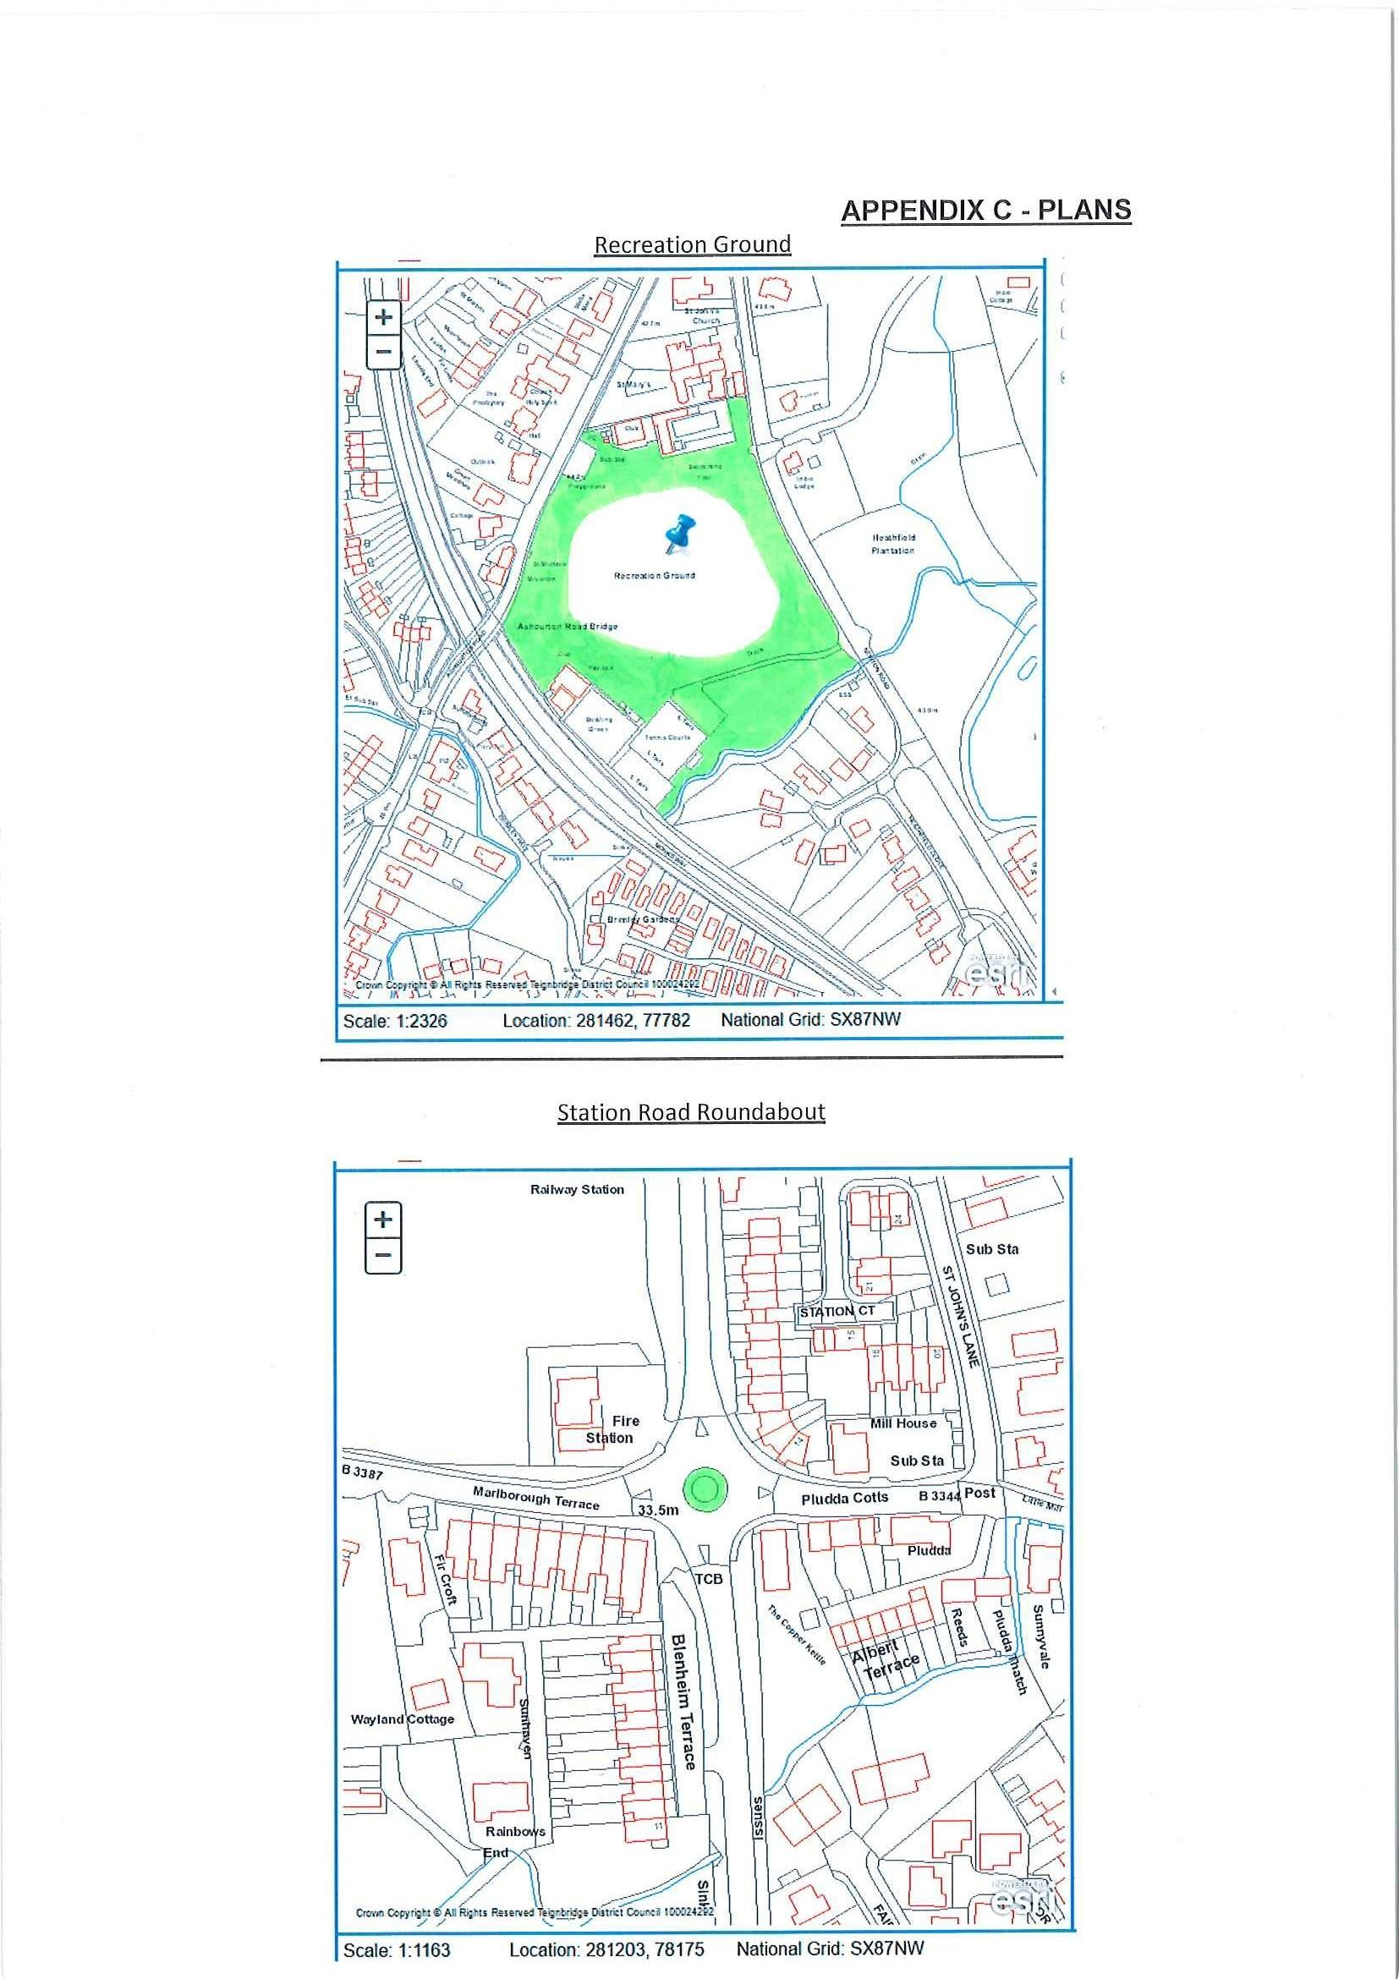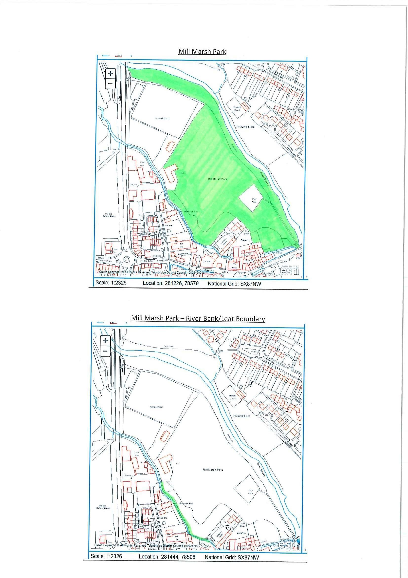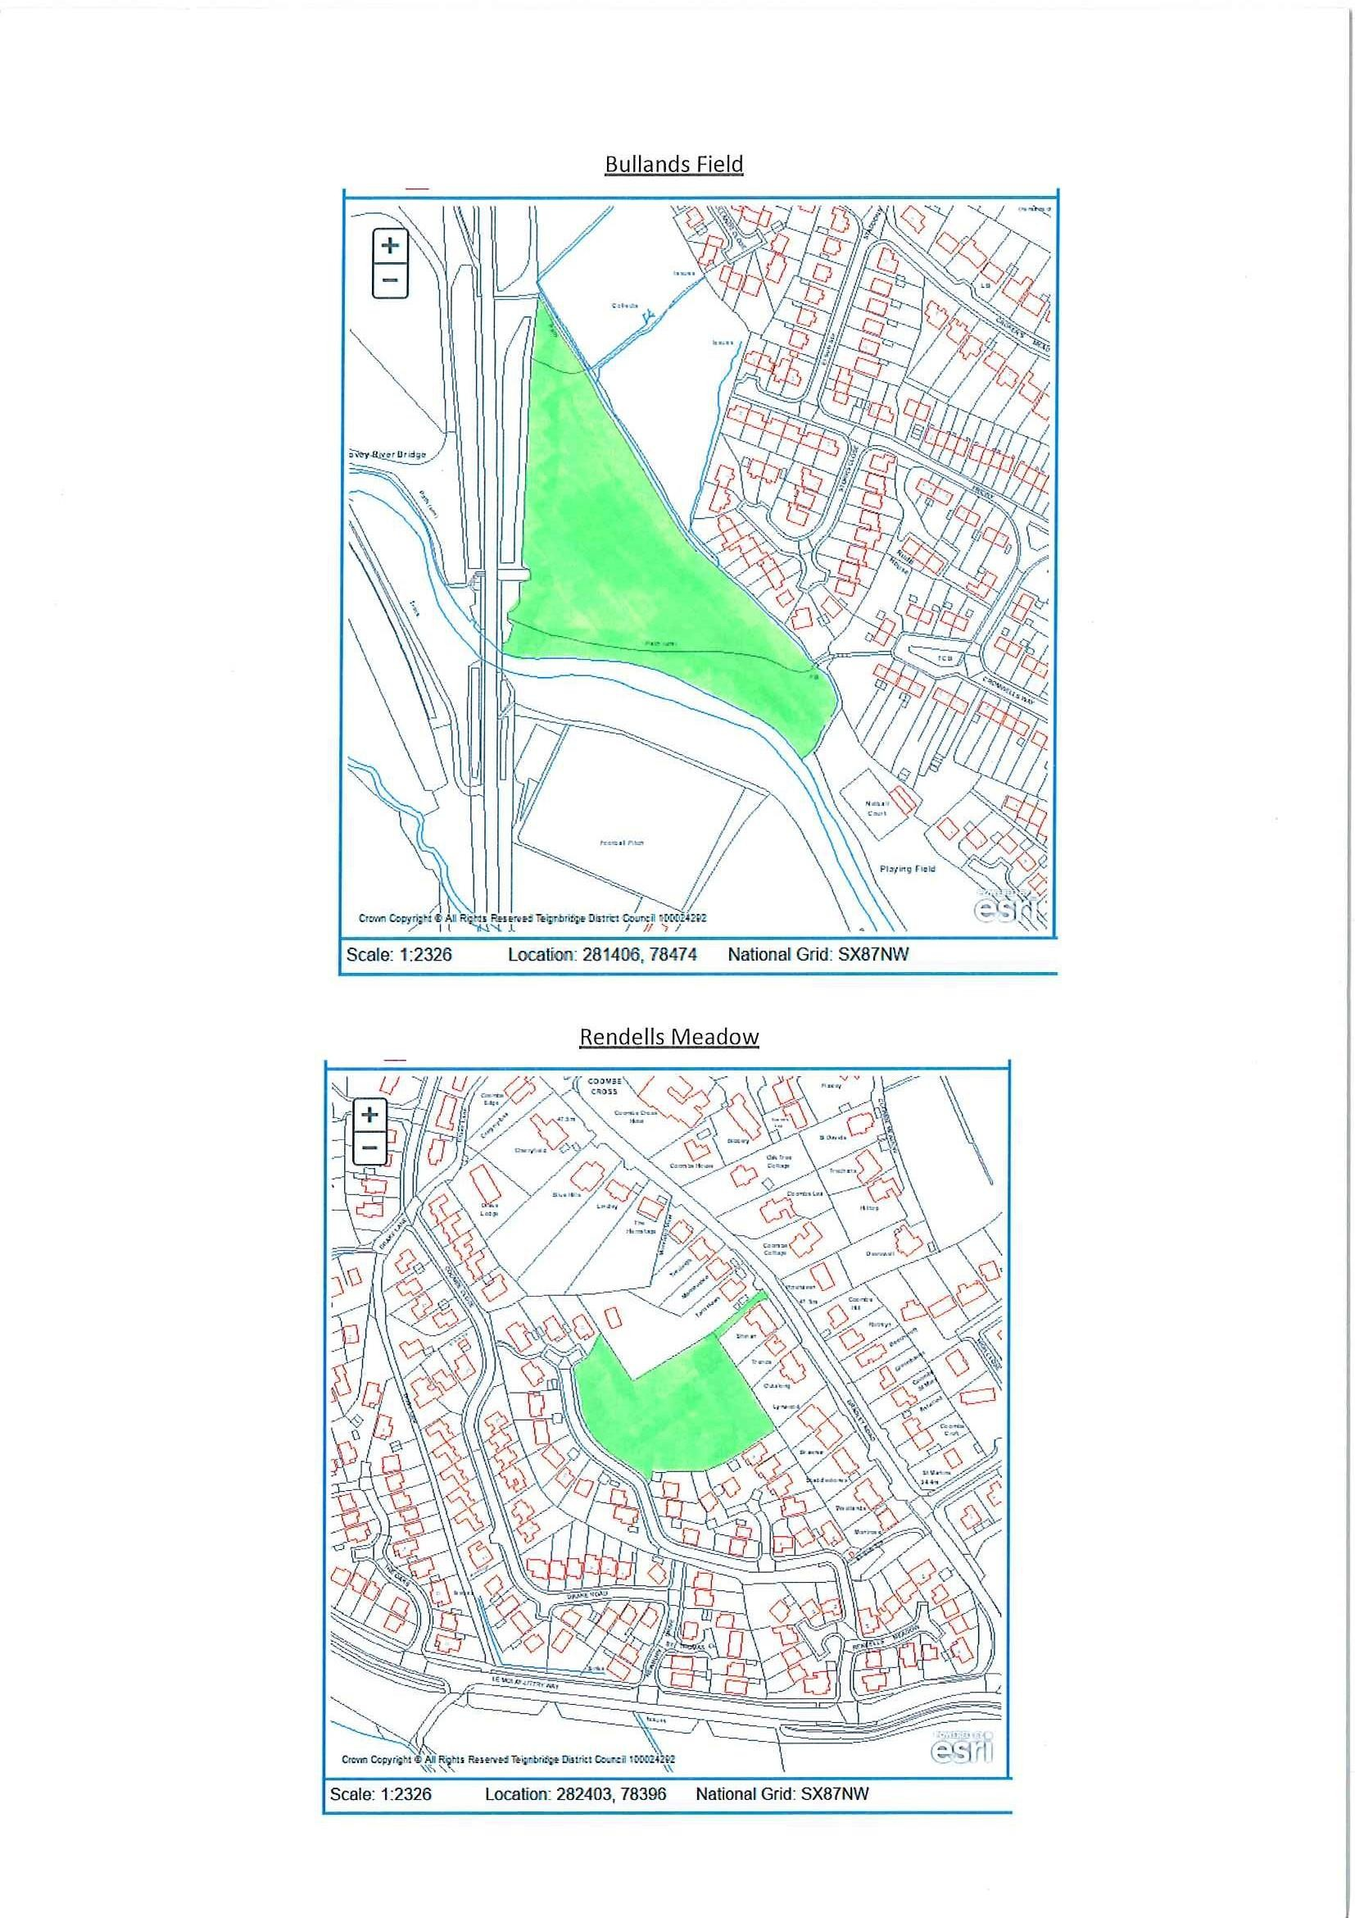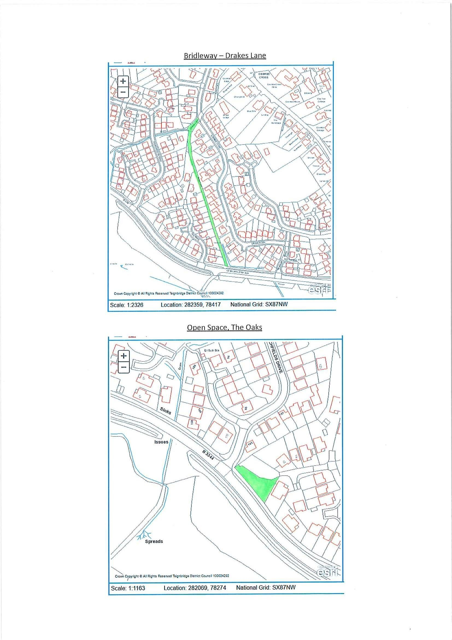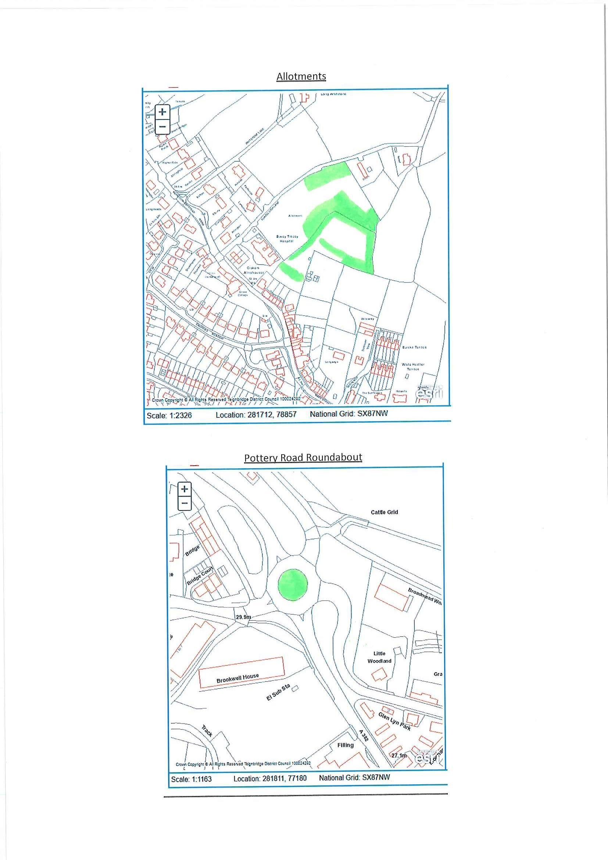

**Temporarily removed**

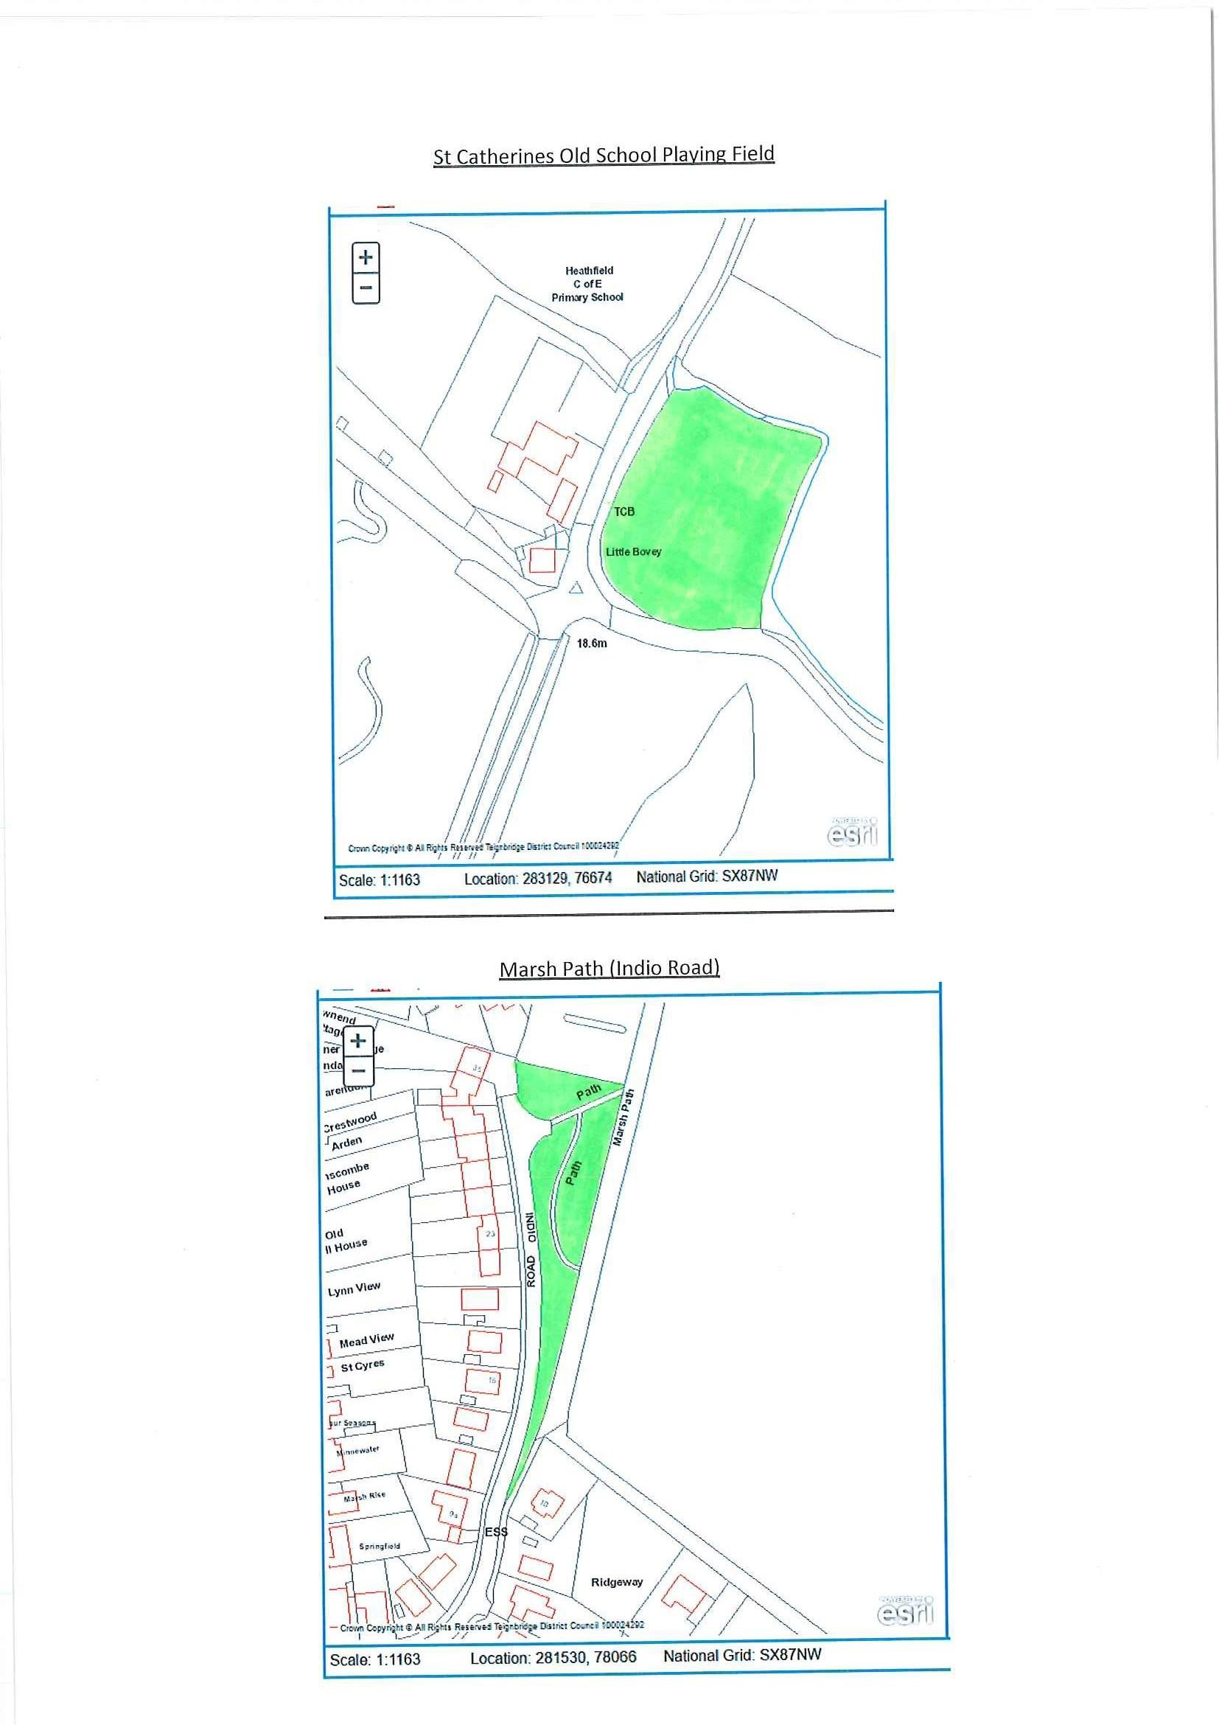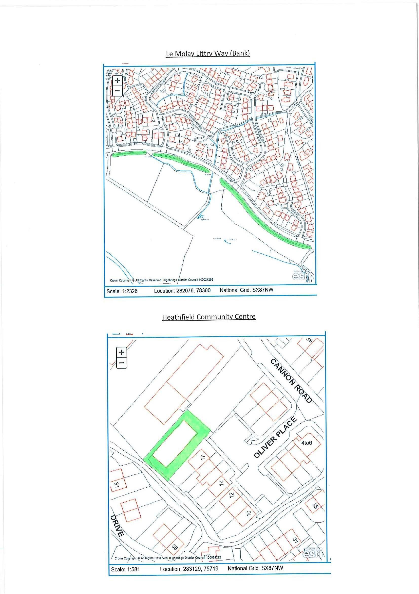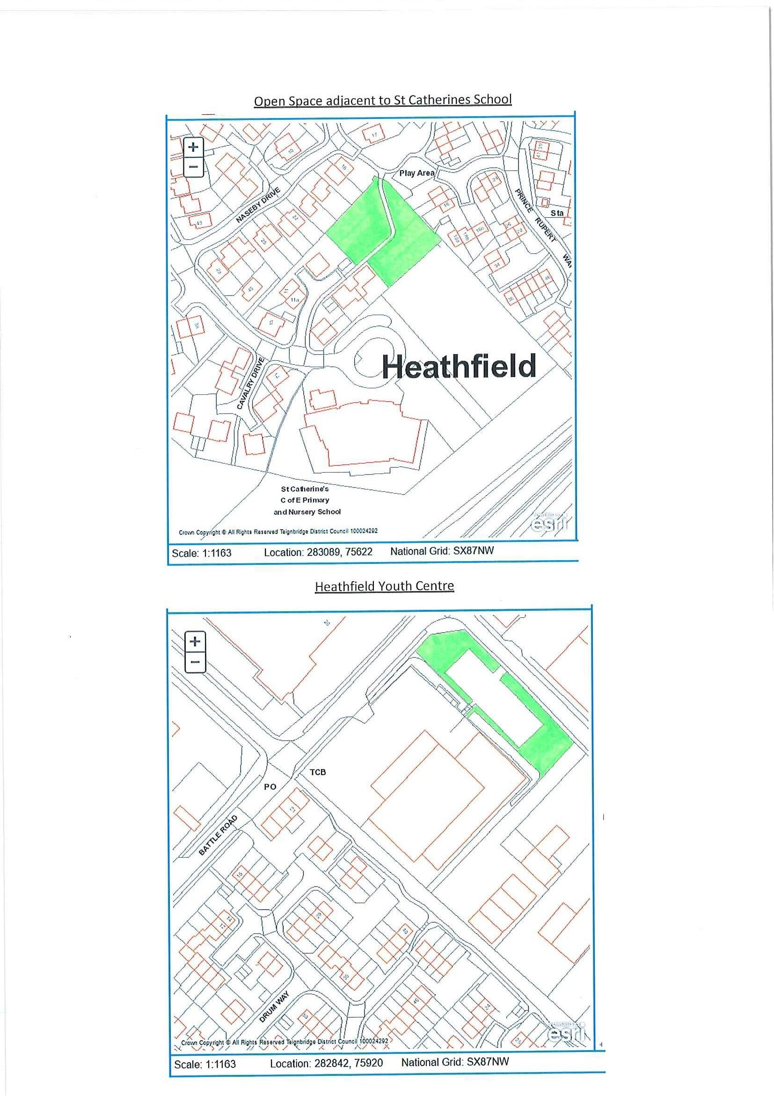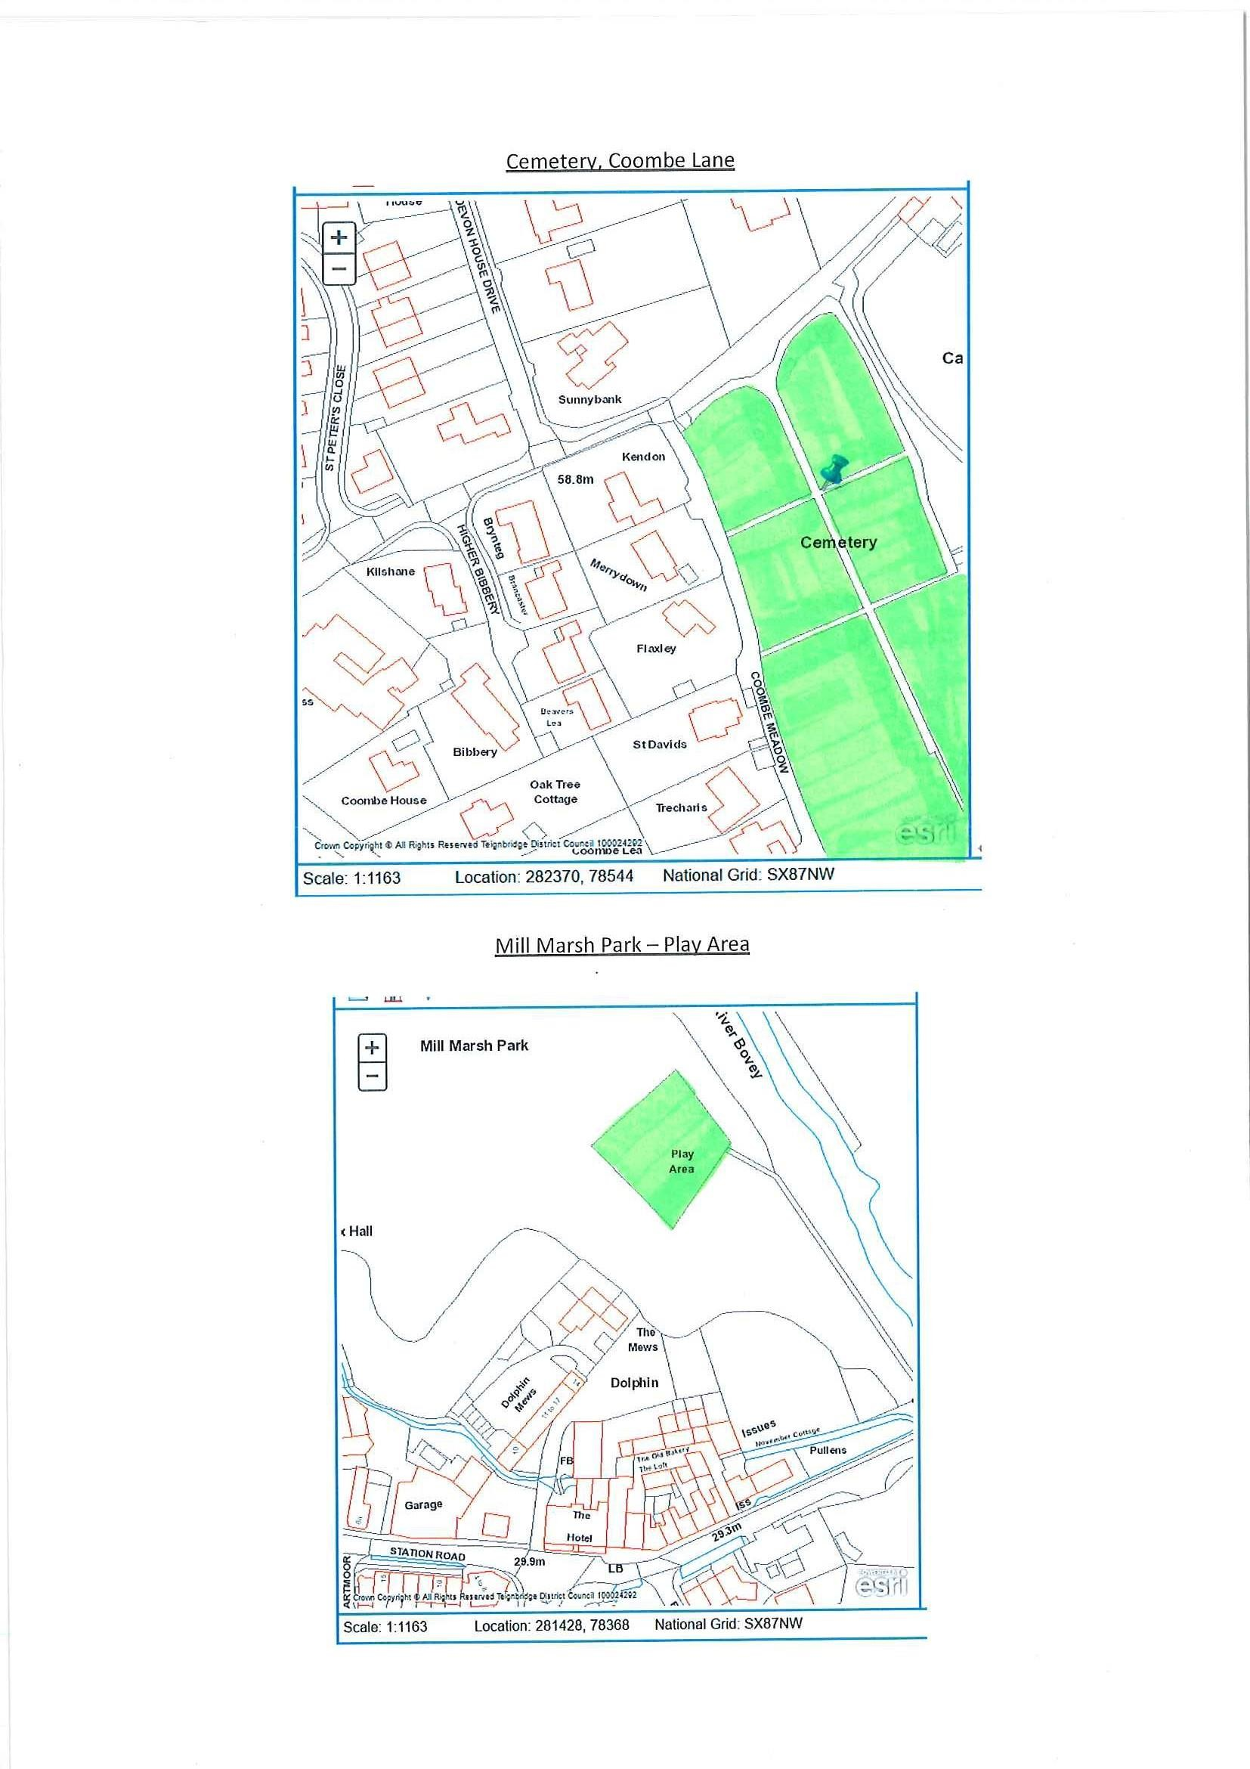

**APPENDIX D – ATTENDANCE SHEET**

**Bovey Tracey Town Council**

Riverside Community Centre

Station Road

Bovey Tracey

**Telephone: 01626 834217**

**Town Clerk:** Mr Mark Wells

**Grounds Maintenance Record Sheet**

**Site Date of Cut Signature**

Cemetery



**Every 12 Working Days**

Mill Marsh Park

Mill Marsh Park Play Area

**(Cut and collect)** Mill Marsh Park Scout Hut Area Mill Marsh Park Skate Park

Recreation Ground

Indio Road

Station Road Roundabout

Pottery Road Roundabout

Mill Marsh Park River Bank/Leat

Boundary

Open Space – Heathfield (Adj to

St Catherine’s Sch)

The Oaks

**Every Other Cut (e.g. Monthly)**

Bullands Field

Allotments

Rendells Meadow

Bridleway - Drake Lane

Heathfield Youth Centre

Old School Field – Heathfield

Le Molay Littry Way Bank

**When Asked**

**APPENDIX E – Envelope Template**

**TENDER FOR GROUNDS MAINTENANCE CONTRACT –**

**NOT TO BE OPENED UNTIL 12 NOON ON MONDAY 19TH AUGUST 2024**