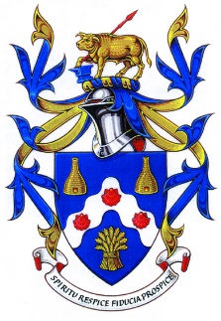
Bovey Tracey Town Council
Green Events Policy

Bovey Tracey Town Council declared a climate emergency and pledged to do whatever it can to make Bovey Tracey and Heathfield carbon neutral. One of the Council’s functions is to support the holding of events within the Parish. As a Council we would like events that are to be held within the Parish, strive to be carbon neutral. In order to support this, we ask that event organisers consider the following when arranging events.

Transport and other Emissions
Reduce CO2 emissions travelling to the venue by providing information about local and public transport.
Promote cycling to and from the event.
Promote car sharing
Catering/Food
Plan food requirements carefully to avoid unnecessary waste
Encourage the use of seasonal and sustainable produce wherever possible
It is preferable that tea and coffee are Fair Trade produce
Waste
Where possible single-use plastics should not be used
Food stalls should serve food in biodegradable food packaging
Use reusable crockery, glassware and cutlery where possible
Event holders are to ensure they hire waste bins in order that the correct recycling of general waste, glass, plastics and tins is carried out. They employ ‘bin monitors’ so that they can check/empty park bins during events organised at weekends when council staff will not be working.
Promotion of event
Please consider the following:
Use websites & email lists to promote the event rather than glossy paper
Use double-sided printing for promotional materials & handouts.
Use recycled paper where possible
Use waterproof paper if possible as this will prevent the need to laminate the paper

The above list is only a snapshot of what can be done by organisers to reduce the carbon
footprint. Further information can be found on various web sites.

