
27th October 2020
Access to the Remote Meeting

The press and public are welcome and are encouraged to attend meetings. The Town Council will however be meeting online using zoom software for the foreseeable future to protect the public and members from spreading the virus. Public with a telephone line or an internet connection can still join the meetings via the link below:

Join Zoom Meeting
https://us02web.zoom.us/j/88378254339?pwd=bGJZZEp2eXBYTVdZM0JaVlR5dmNmUT09

Meeting ID: 883 7825 4339
Passcode: 582928

Find your local number: https://us02web.zoom.us/u/kdIkCp9fl9 Note: Calls are charged at zoom rates and are payable by the user. More information at http://zoom.us/zoomconference/rates

To Members of the Finance, Resources & General Purposes Committee

Cllrs Brooke (Ex Officio), Allen, Bradshaw, Brooke, Elphick, Fletcher, Gribble & Mills.

Cc All other Members of the Council for information.

Dear Councillor,

You are hereby summoned to attend a virtual meeting of the Finance, Resources and General Purposes (FR&GP) Committee on Monday 2nd November 2020 at 7pm for the purpose of transacting the business as set out below.

AGENDA

Interests to be Declared: In accordance with the Code of Conduct, Members are invited to declare any personal or disclosable pecuniary interests, including the nature and extent of such interests, they may have in items to be considered at this meeting. Members are also reminded that any change to their Declaration of Interests must be notified to the Monitoring Officer at Teignbridge District Council within 28 days of the change.

FR&GP.20/48 Apologies for absence:

**Public Participation:

The Committee, at the Chairman’s discretion, sets aside a short period of time at the commencement of the meeting when the public can ask questions or make statements regarding agenda items.

FR&GP.20/49 Minutes:

To agree as a correct record and approve the minutes of the meeting of 7th September
2020 (*copy enclosed).

FR&GP.20/50 Standing Item – Climate Emergency:

To note the Council Declaration and to embed the climate emergency declaration across all Council services, activities, plans and other relevant work, considering the environmental impact of decisions, ensuring a fully integrated approach to mitigating the impact of climate change. The Council’s Climate Emergency Bovey & Heathfield Working Group leads and coordinates these activities.

FR&GP.20/51 Accounts & Financial Statement:

To receive and approve:
i) payment and receipt transactions between 30th August 2020 and 23rd October 2020 (*copy enclosed).
ii) bank reconciliation between 28th August 2020 and 23rd October 2020 (*copy enclosed).
iii) note the bank balances as below:
General Account: £ 6,372.45 (as at 23.10.20)
Business Bank Instant A/C: £ 201,312.85 (as at 23.10.20)
Lloyds Deposit A/C: £ 123,385.39 (as at 23.10.20)
Lloyds CIL A/C: £ 25,979.11 (as at 23.10.20)
Covid19 Hardship Fd A/C: £ 300.01 (as at 23.10.20)

FR&GP.20/52 Covid 19 – Hardship Fund (Deferred Item FR&GP.20/45):

To receive and consider DRAFT Terms & Conditions for the consideration of future Hardship Fund requests (*copy enclosed).

FR&GP.20/53 Budget Monitoring – Position Statement:
To note the Town Council’s half yearly budget monitoring statement as at 23rd October 2020 (*copy enclosed).

FR&GP.20/54 Riverside Community Centre:

i) Fees & Charges/Terms & Conditions of Hire & Rental Agreement

To receive and consider approving:
a) Terms and Conditions of Hire and corresponding Fees and Charges (*copy enclosed).
b) Incubation Office Rental Agreement (*copy enclosed).

ii) CCTV and Audi Visual Requirements

To receive and consider the Assistant Town Clerk’s report for the supply and installation of internal CCTV equipment and Audio/Visual facilities (*copy enclosed).

iii) Public Toilet Facilities (Station Road)

To receive and consider further information and costs from Teignbridge DC (if received).

FR&GP.20/55 Town Council – Bank Mandate
To consider and approve the following amendments to the Council’s banking mandate:
i) Removal of Mrs L Warren
ii) Addition of Ms N Elford
iii) Change of Business Address

FR&GP.20/56 Grant Awarding Policy
To review and approve the current Grant Awarding Policy (*copy enclosed).
FR&GP.20/57 Matters brought forward by Councillors: (for information only).

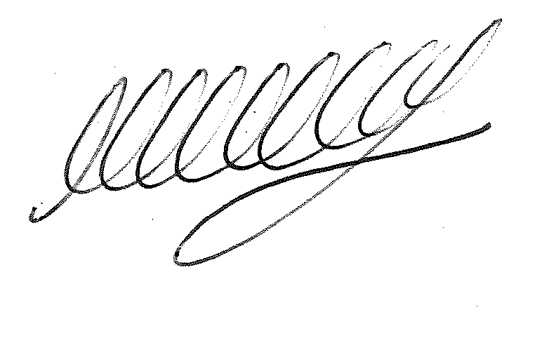

SIGNED DATE: 27th October 2020

M WELLS - TOWN CLERK

*Copies of correspondence circulated to Councillors with this agenda, which will be considered at the meeting.

